November 14, 2012

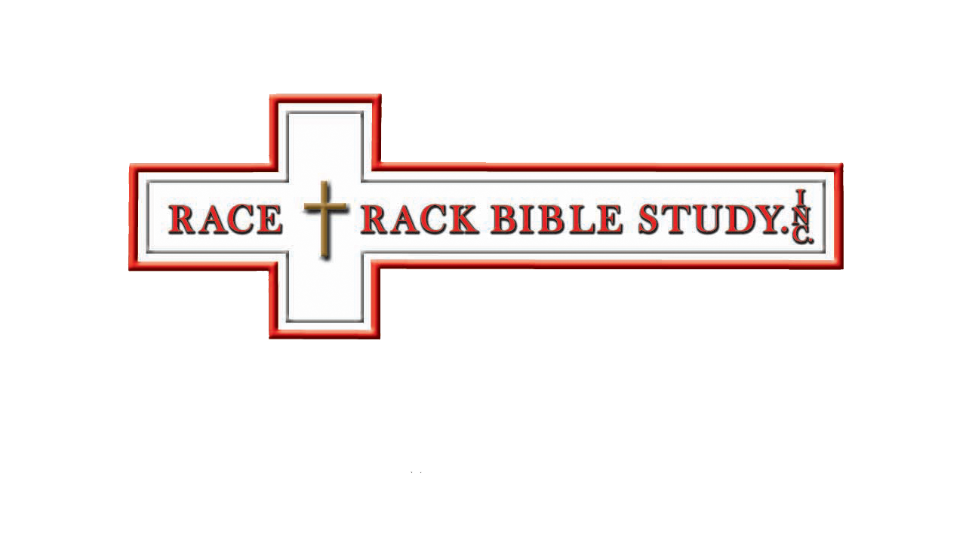

Enter Contact Information Here | 1127 Lombard Blvd. San Francisco, CA 59802 | phone 555.555.5555 | fax 555.555.5555

­

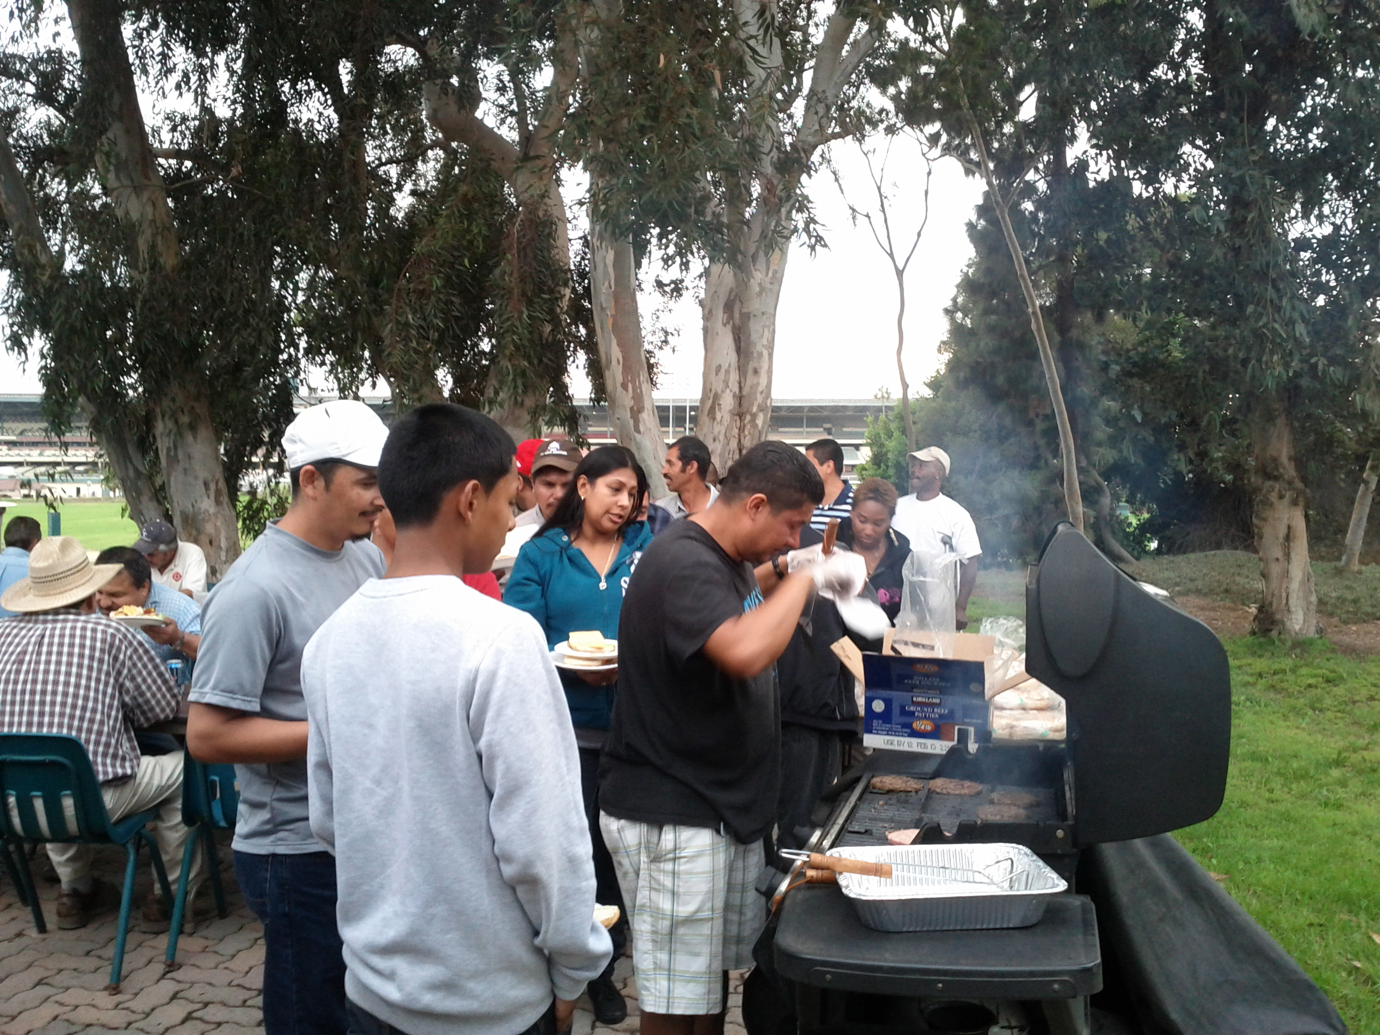

BBQ Outreach at Hollywood Park (above)

Devotion with PBR Bullriders, Del Mar, CA (below)

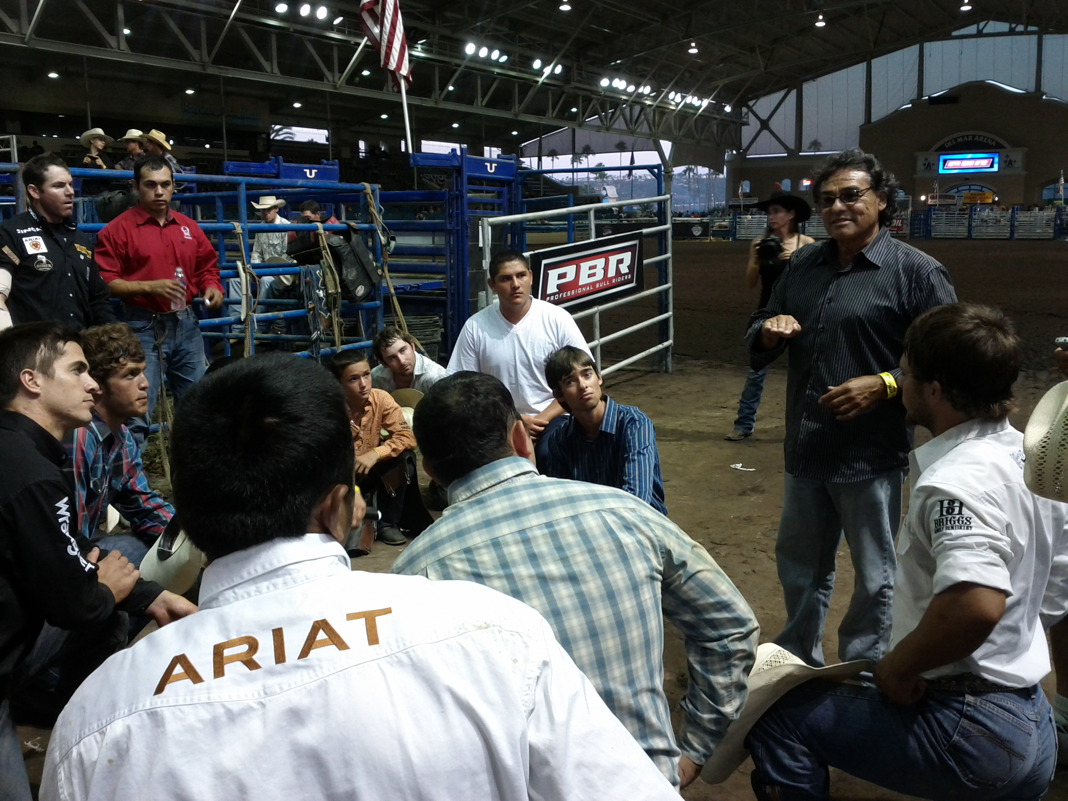

Gift Raffle Winners At Retama Pk, San Antonio, Texas (below)

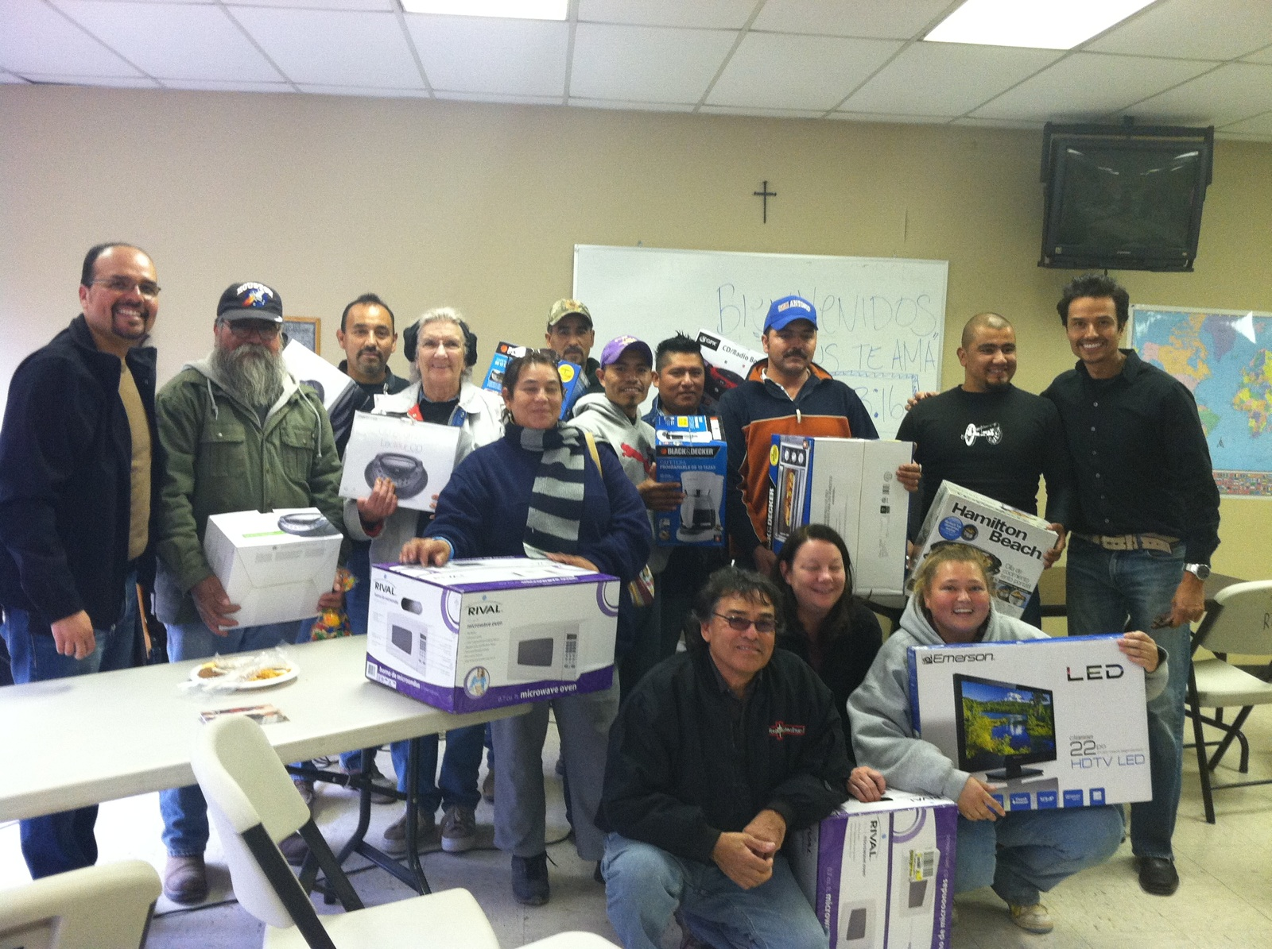

Delete text and place photo here.

It would be a blessing and our privilege to visit your venue wherever it may be worldwide. Please don’t hesitate to contact us for this or for prayer. Our website is located at [www.racetrackbiblestudy.com](http://www.racetrackbiblestudy.com) and our email is [racetrackbiblestudy@yahoo.com](mailto:racetrackbiblestudy@yahoo.com). Please follow us on Twitter at @RacetrackBibles and Facebook .

Welcome to the inaugural newsletter of Racetrack Biblestudy.

Many of you already know who we are. For those of you that are not familiar with us we are a non-profit 501(C) (3) organization.

Our primary function is to go out in conjunction with the music duo Gutierrez Bros. and host missionary Christian outreaches at horse racetracks throughout the country. These outreaches consist of our organization providing a complimentary meal, entertainment, gifts and share His word of hope.

We have the desire to go out worldwide to other non- horse racing venues. We are available for devotion and prayer to cover your event. We are self-funded. We have served PBR bull riders and horse shows with a short devotion and prayer as well.

This past Tuesday afternoon we were blessed to have served around 100 people a lunch, gifts and a Holy-Spirit filled word that was well received at Retama Park in San Antonio, Texas. We look forward to visiting Retama again next year.

In addition

Racetrack Bible Study, Inc. | P.O. Box 1506, Duarte, California 91009 | phone 626.536.5413 |951.207.5833

**1 Corinthians 15:58**

Welcome!

